MassTransit Research Notes

# Notes

* Nuget Packages:
  + MassTransit
  + MassTransit.MSMQ
  + MassTransit.Log4Net
  + MassTransit.Courier -   
    An implementation of the routing slip pattern (EIP: Routing Slip), including activity execution and compensation, for MassTransit.
  + MassTransit.QuartzIntegration -   
    Adds support for Quartz as a message scheduler to MassTransit
* Uses Magnum package for State Machine workflow.
  + Used to create SagaStateMachine
* What is the Data Bus?  
  The data bus is the instance of IServiceBus that you will work with day in and day out. It is the instance that listens at msmq://localhost/servicea that you configured at start up. This is typically the one you want set to transactional queues and want to be careful about just randomly purging.
* What is a Control Bus?  
  <http://www.eaipatterns.com/ControlBus.html>   
  The idea of the control bus is one that responds to control messages. That is to say, not the messages and events that are running your business. It is recommended that the control messages also be sent on a separate Endpoint or in our case a different RabbitMQ Queue or MSMQ Queue.  
    
  By setting the control bus up on a different Endpoint control messages can’t get blocked by data messages and vice versa. We use this to do various things such as reload configuration data, clear caches, or check on the health of our distributed services.

# Sample Projects

* Starbucks
  + Starbucks.Messages project contains POCO message classes.
  + Executable
    - \Starbucks.Barista\bin\Debug\Starbucks.Barista.exe
    - \Starbucks.Cashier\bin\Debug\Starbucks.Cashier.exe
    - \Starbucks.Customer\bin\Debug\Starbucks.Customer.exe
  + MSMQ
    - Queues are setup by MassTransit.
    - Console apps are both services and clients.
    - MSMQ reference is only to the parent queue level.

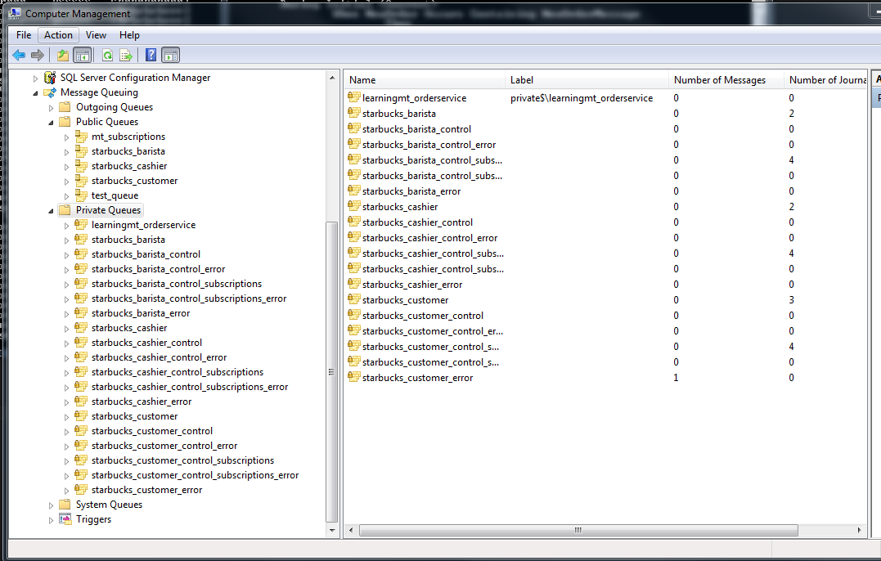

* + Magnum Saga Notes:
    - Implements the ISaga interface
    - Has a STATE type
    - Implements Messages as Events.

# MSMQ Research

# Logging

* Logging in MassTransit   
  <http://masstransit.readthedocs.org/en/latest/overview/logging.html>
* Log4Net is the standard.   
  MassTransit.Log4Net package is available at:  
  https://nuget.org/packages/MassTransit.Log4Net.
* NLog is another option with MassTransit.NLog package.  
  <https://nuget.org/packages/MassTransit.NLog>

# Training

* Chris Patterson’s Talk on Event Driven Architectures  
  <http://northdallas.net/videos/event-driven-architecture/>  
  <http://usergroup.tv/videos/event-driven-architecture>  
  <http://www.slideshare.net/PhatBoyG/event-driven-architecture-1934104>
* Event Driven Architecture
* Click Driven Development with Tibco –
* CAP Theorem:  
  